SHORT RANGE PERSONAL RADAR USING ULTRASONIC SENSOR

A PROJECT REPORT

Submitted by

PRIYA DHOOT

[09EJTEC090]

PRIYA SAINI

[09EJTEC091]

in partial fulfillment for the award of the degree
of

BACHELOR OF TECHNOLOGY

in

ELECTRONICS &COMMUNICATION ENGINEERING



JIET-SCHOOL OF ENGINEERING & TECHNOLOGY FOR GIRLS,

Jodhpur

OCTOBER 2012

JIET-SCHOOL OF ENGINEERING & TECHNOLOGY FOR GIRLS

CERTIFICATE

Certified that this project report “SHORT RANGE PERSONAL RADAR USING ULTRASONIC SENSOR”
is the bonafide work of “PRIYA DHOOT” who carried out the project work under my supervision.

SIGNATURE SIGNATURE

Prof. Sanjay Gaur Nabenbdra Rai
HEAD OF THE DEPARTMENT LAB INCHARGE
ECE ECE

JIET-SCHOOL OF ENGINEERING & TECHNOLOGY FOR GIRLS

CERTIFICATE

Certified that this project report “SHORT RANGE PERSONAL RADAR USING ULTRASONIC SENSOR”
is the bonafide work of “PRIYA SAINI” who carried out the project work under my supervision.

SIGNATURE SIGNATURE

Prof. Sanjay Gaur Nabenbdra Rai
HEAD OF THE DEPARTMENT LAB INCHARGE
ECE ECE

JIET-SCHOOL OF ENGINEERING & TECHNOLOGY FOR GIRLS

CERTIFICATE

Certified that this project report “SHORT RANGE PERSONAL RADAR USING ULTRASONIC SENSOR”
is the bonafide work of “PRIYA DHOOT, PRIYA SAINI” who carried out the project work under my supervision.

SIGNATURE SIGNATURE

Prof. Sanjay Gaur Nabenbdra Rai
HEAD OF THE DEPARTMENT LAB INCHARGE
ECE ECE

TABLE OF CONTENTS

CHAPTER NO. TITLE PAGE NO.

1. Abstract
2. List of table

3. List of figures
4. List of symbols
5. Chapter 0: introduction about the project
6. Chapter 1: brief about the circuit description and working process
7. Chapter 2: introduction of mainly used components
8. Chapter 3: pcb fabrication by using eagle software
9. Chapter 4: conclusion

References

ABSTRACT

The project “Short Range Personal Radar System” is basically an object detector in which detection of obstacles is done by a sensor which can be ranges from some cm to few meters. The process of get data from sensor and to show the output on a LED pattern is whole implemented by a microcontroller IC.

We have divided this project in two stages in which following steps are taken:

- Stage I: In this stage hardware of this project is done which includes PCB fabrication (layout pasting, drilling, etching, component mounting and soldering). Also, a led pattern according to the five latch ic’s is made for see the output. Due to some complications in circuit simulation we are used Double sided pcb for latches.

- Stage II: In this stage the programming part of the microcontroller will be done using MPLAB IDE software for PIC simulation. Since the coding for this will be in C-language thus we will use a C-compiler for this.

Therefore, for this stage of the project we have done the hardware making.

CHAPTER 0
INTRODUCTION ABOUT THE PROJECT

Aim of the project: The goal of this project is to create a working ultrasonic sensor radar system. The system will only be required to measure close proximity at an angle of 90 degrees. The range of system is roughly 4-30cm, 20-150cm & 1m-5.5m depending upon the type of sensor which we are using for this project. For high accuracy and resolution we have chosen ultrasonic sensor which will detect any moving or non-moving objects or obstacles in range of approximate 4m.

As we earlier described in abstract part of this report that the whole process will be done by PIC microcontroller. Some new objects for which we are newly introduced are Servo motor, ultrasonic sensor and PIC Microcontroller.

The entire description about its working principle, circuit diagram used for this and an overview about the components mainly used to implementation of hardware is given in several chapters.

CHAPTER 1: Brief about the circuit description and working process in detail.

CHAPTER 2: Introduction of mainly used components

CHAPTER 3: Hardware making (PCB Fabrication by using Eagle software)

CHAPTER 4: Conclusion

The outcome of this project will shape future projects where we try to integrate such a radar system to help navigate mobile robots through the real world. This system may useful in parking system, for security purposes, on highways in night time to preventing the accidents and in several many applications.

CHAPTER 1
BRIEF ABOUT THE CIRCUIT DESCRIPTION AND WORKING PROCESS

Circuit Diagram:
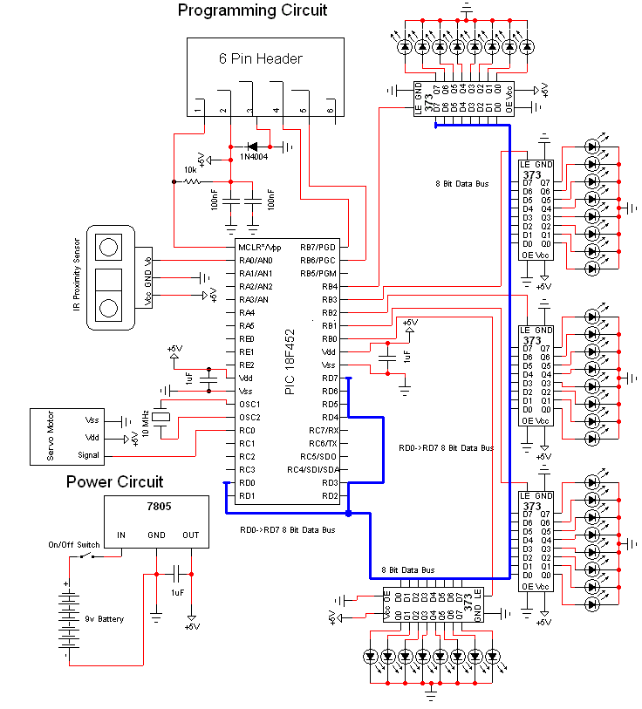

Fig. 1(a) circuit diagram of short range personal radar

Schematic Specifics-
Power Circuit:
The power circuit is a 9v Battery hooked up to the LM7805 with a 1uF capacitor hooked to output & ground of the LM7805 to keep a steady 5v DC or we can get it from the mains after converting the ac supply into dc 5volts using bridge rectifier and 7805 voltage regulator ic..
Programming Circuit:
The programming circuit is made by hooking up two pins from the PIC to the programmer and allowing the programmer's pin 1 access to the MCLR*/Vpp-Pin1 on the PIC. We put a rectifier diode in there for safety as well.
Ultrasonic Sensor:
The Ultrasonic Sensor only uses 1 pic from the pic, PIN 2 - RA0. It will use the analog feature of this pin to get an ADC value as the proximity sensor only outputs analog voltages. This value will tell us the if anything is near the sensor in our environment.
LEDs Output:
There are 40 LEDs in total. Since each 74HCT373 latch IC can control up to 8 led’s; 40/8 = 5 we'll need to use 5 74HCT373's to be able to control all 40 LEDs. It is important to notice on the schematic that a common data bus is used between all the 5 chips which is connected in cascading.

CHAPTER 2
Introduction of Mainly Used Components

S.no. | Name of Component | Quantity | Specification
1. | PIC 18F452 Microcontroller | 1
2. | LM7805 5v Voltage Regulator | 1
3. | HC SR04 Ultrasonic Sensor | 1
4. | HS-322HD Standard Heavy Duty Motor | 1
5. | 10 MHz Oscillator | 1
6. | SPST Switch | 1
7. | 6-pin Header | 1
8. | 1µF Capacitor | 2
9. | 10K ohm Resistor | 1
10. | 1N4007 diode | 1
11. | 40 pin SIPs | 2
12. | 74LS373 Latches | 5
13. | Red LED | 40
14. | Double sided pcb | 1
15. | Single sided pcb | 2
16. | Bus connectors | 6
17. | Solder | 1
18. | Wire 30 AWG (aka Wirewrap) | 1
19. | Wirewrap Tool | 1
20. | Soldering Iron | 1

Table 2(a) List of components

- PIC 18F452 Microcontroller:
Parameter Name | Value
Program Memory Type | Flash
Program Memory (KB) | 32
CPU Speed (MIPS) | 10
RAM Bytes | 1,536
Data EEPROM (bytes) | 256
Digital Communication Peripherals | 1-A/E/USART, 1-MSSP(SPI/I2C)
Capture/Compare/PWM Peripherals | 2 CCP
Timers | 1 x 8-bit, 3 x 16-bit
ADC | 8 ch, 10-bit
Temperature Range (C) | -40 to 125
Operating Voltage Range (V) | 2 to 5.5
Pin Count | 40
Fig 2(a) pin diagram of PIC18f452

Summary:
This powerful 10 MIPS (100 nanosecond instruction execution) yet easy-to-program (only 77 single word instructions) CMOS FLASH-based 8-bit microcontroller packs Microchip's powerful PIC® architecture into an 40- or 44-pin package and is upwards compatible with the PIC16C5X, PIC12CXXX, PIC16CXX and PIC17CXX devices and thus providing a seamless migration path of software code to higher levels of hardware integration. The PIC18F452 features a 'C' compiler friendly development environment, 256 bytes of EEPROM, Self-programming, an ICD, 2 capture/compare/PWM functions, 8 channels of 10-bit Analog-to-Digital (A/D) converter, the synchronous serial port can be configured as either 3-wire Serial Peripheral Interface (SPI™) or the 2-wire Inter-Integrated Circuit (I²C™) bus and Addressable Universal Asynchronous Receiver Transmitter (AUSART). All of these features make it ideal for manufacturing equipment, instrumentation and monitoring, data acquisition, power conditioning, environmental monitoring, telecom and consumer audio/video applications.

Features
  - 2 PWM 10-Bit
  - 40 MHz Max. Speed
  - Self-Programming
  - PSP
  - ICD

CPU
  - Up to 10 MIPS Performance at 3V
  - C compiler optimized RISC architecture
  - 8x8 Single Cycle Hardware Multiply

System
  - Internal oscillator support-31 kHz to 8MHz with 4xPLL
  - Fail-Safe Clock Monitor- allows safe shutdown if clock fails
  - Watchdog Timer with separate RC oscillator
  - Wide operating Voltage range; 2.0V to 5.5V

Nano Watt Power Managed Modes
  - Run, Idle and SLEEP modes
  - Idle mode currents down to 5.8uA typical
  - Sleep mode currents down to 0.1uA typical

Analog Features
  - 10-bit ADC, 13 channels, 100K samples per second
  - Programmable Low Voltage Detection Module
  - Programmable Brown-out-Reset Module
  - Two Analog Comparators multiplexing

Peripherals
  - Master Synchronous Serial Port supports SPI™ and I2C™ master and slave mode
  - EUSART module including LIN bus support
  - Four Timer modules
  - Up to 5 PWM outputs
  - Up to 2 Capture / Compare

LM7805 5v Voltage Regulator: IC-7805 is a 5v Voltage regulator that restricts the voltage output to 5 volt comes with provision to add heat sink .The maximum value for input to the power | Voltage regulator is 35 v. it can provide a constant steady voltage flow of 5 v for higher voltage input till the threshold limit of 35v. If the voltage is near to7.5 v then it does not produce any heat and hence no need for heat sink. If the voltage input is more then the heat produced is more.It gives steady output if the voltage is in rage of 7.2v to35 v.
In some circuitry voltage fluctuation is fatal, for such situation to ensure constant voltage
IC-7805 Voltage Regulators are used.

- HC SR04 Ultrasonic Sensor:
Product features:
Ultrasonic ranging module HC - SR04 provides 2cm - 400cm non-contact measurement function, the ranging accuracy can reach to 3mm. The modules includes ultrasonic transmitters, receiver and control circuit. The basic principle of work:
(1) Using IO trigger for at least 10us high level signal,
(2) The Module automatically sends eight 40 kHz and detect whether there is a
pulse signal back.
(3) If the signal back, through high level , time of high output IO duration is
the time from sending ultrasonic to returning.
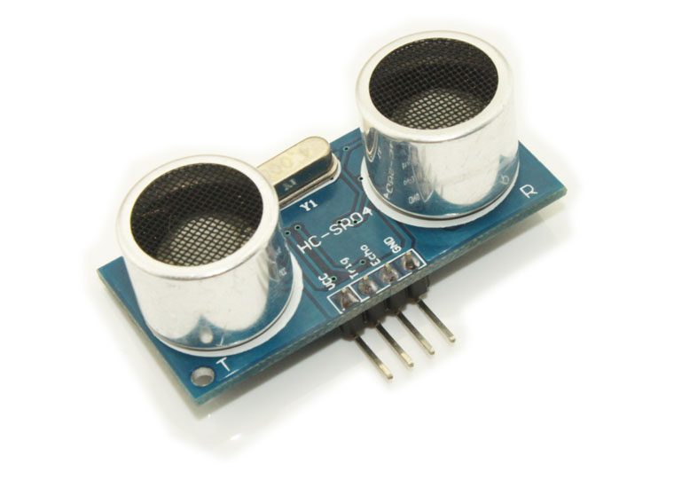
Fig 2(b) diagram of HC SR04 ultrasonic sensor

Test distance = (high level time×velocity of sound (340M/S) / 2,
Wire connecting direct as following:
_ 5V Supply
_ Trigger Pulse Input
_ Echo Pulse Output
_ 0V Ground
Electric Parameter
Working Voltage DC 5 V
Working Current 15mA
Working Frequency 40Hz
Max Range 4m
Min Range 2cm
MeasuringAngle 15 degree
Trigger Input Signal 10uS TTL pulse
Echo Output Signal Input TTL lever signal and the range in proportion
Dimension 45*20*15mm

- HS-322HD Standard Heavy Duty Motor:
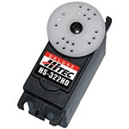

Fig 2(c) diagram of servo motor

SERVO MOTORS
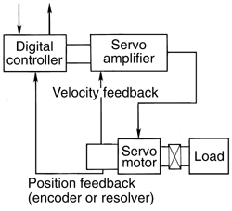
Fig2(d) - Typical dc servo motor system with either encoder or resolver feedback. Some older servo motor systems use a tachometer and encoder for feedback.

Servo motors are used in closed loop control systems in which work is the control variable, Figure 9. The digital servo motor controller directs operation of the servo motor by sending velocity command signals to the amplifier, which drives the servo motor. An integral feedback device (resolver) or devices (encoder and tachometer) are either incorporated within the servo motor or are remotely mounted, often on the load itself. These provide the servo motor's position and velocity feedback that the controller compares to its programmed motion profile and uses to alter its velocity signal. Servo motors feature a motion profile, which is a set of instructions programmed into the controller that defines the servo motor operation in terms of time, position, and velocity. The ability of the servo motor to adjust to differences between the motion profile and feedback signals depends greatly upon the type of controls and servo motors used. See the servo motors Control and Sensors Product section.
Three basic types of servo motors are used in modern servo systems: ac servo motors, based on induction motor designs; dc servo motors, based on dc motor designs; and ac brushless servo motors, based on synchronous motor designs.

DC servomotors
Rare Earth Magnet Type 30, 60, 100, 200W

Features:
- Realization of smaller size and lighter weight by adopting high performance rare earth magnet.
- Tremendous characteristics of servo motors by lessening inertia and by upping power rate and response.
- Dust-proof and water-proof construction
- Wide series ranging from 30to 200 watts
- Heat improvement by incorporating with aluminum die-castings (Only 200 watt type is applicable.)
- Smooth rotation realized by multi-slot design and expansion into a low speed range
- Advancement of noise immunity and realization of unique shrunken motors
- Various optional combinations with tachogenerators, encoders or supporting brakes are possible.
- Realization of ultra-thin encoders with newly designed hybrid IC (Option)
4. 10 MHz Oscillator:
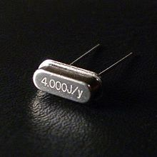
Fig 2(e) diagram of 4 MHz crystal ocsillator
A crystal oscillator is an electronic oscillator circuit that uses the mechanical resonance of a vibrating crystal of piezoelectric material to create an electrical signal with a very precise frequency. This frequency is commonly used to keep track of time (as in quartz wristwatches), to provide a stable clock signal for digital integrated circuits, and to stabilize frequencies for radio transmitters and receivers. The most common type of piezoelectric resonator used is the quartz crystal, but other piezoelectric materials including polycrystaline ceramics are used in similar circuits.
Quartz crystals are manufactured for frequencies from a few tens of kilohertz to tens of megahertz. More than two billion crystals are manufactured annually. Most are used for consumer devices such as wristwatches, clocks, radios, computers, and cellphones. Quartz crystals are also found inside test and measurement equipment, such as counters, signal generators, and oscilloscopes.
5. Fixed Value Resistor : The diagram shows the construction of a carbon film resistor:
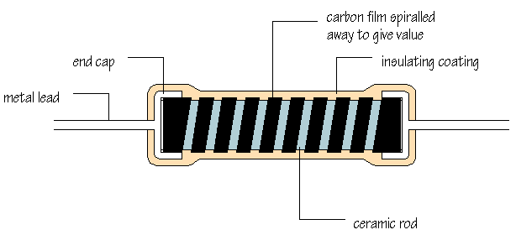
Fig 2(f) fixed value resistor
During manufacture, a thin film of carbon is deposited onto a small ceramic rod. The resistive coating is spiralled away in an automatic machine until the resistance between the two ends of the rod is as close as possible to the correct value. Metal leads and end caps are added, the resistor is covered with an insulating coating and finally painted with coloured bands to indicate the resistor value.
Carbon film resistors are cheap and easily available, with values within ±10% or ±5% of their marked, or 'nominal' value. Metal film and metal oxide resistors are made in a similar way, but can be made more accurately to within ±2% or ±1% of their nominal value. There are some differences in performance between these resistor types, but none which affect their use in simple circuits.
Wirewound resistors are made by winding thin wire onto a ceramic rod. They can be made extremely accurately for use in multimeters, oscilloscopes and other measuring equipment. Some types of wirewound resistors can pass large currents without overheating and are used in power supplies and other high current circuits.
Colour code
How can the value of a resistor be worked out from the colours of the bands? Each colour represents a number according to the following scheme:
Number | Colour
0 | black
1 | brown
2 | red
3 | orange
4 | yellow
5 | green
6 | blue
7 | violet
8 | grey
9 | white
The first band on a resistor is interpreted as the FIRST DIGIT of the resistor value. For the resistor shown below, the first band is yellow, so the first digit is 4:
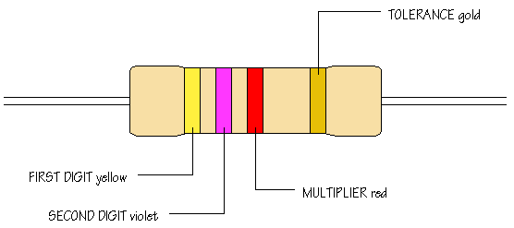
Fig 2(g) color coding of resistor
The second band gives the SECOND DIGIT. This is a violet band, making the second digit 7. The third band is called the MULTIPLIER and is not interpreted in quite the same way. The multiplier tells you how many noughts you should write after the digits you already have. A red band tells you to add 2 noughts. The value of this resistor is therefore 4 7 0 0 ohms, that is,
4 700 , or 4.7 . Work through this example again to confirm that you understand how to apply the colour code given by the first three bands.
The remaining band is called the TOLERANCE band. This indicates the percentage accuracy of the resistor value. Most carbon film resistors have a gold-coloured tolerance band, indicating that the actual resistance value is with + or - 5% of the nominal value. Other tolerance colours are:
Tolerance | Colour
±1% | brown
±2% | red
±5% | gold
±10% | silver
When you want to read off a resistor value, look for the tolerance band, usually gold, and hold the resistor with the tolerance band at its right hand end. Reading resistor values quickly and accurately isn't difficult, but it does take practice!

6. 1N4007 diode:

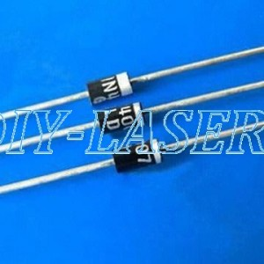
Fig 2(h) diagram of 1N4007 diode
7. 74HCT373:
This chip is an octal d flip-flop tri-state latch. In english that means that this chip is capable of storing 8 bits of digital logic and holding that memory until it is cleared or changed via the LE-Latch Enable pin.
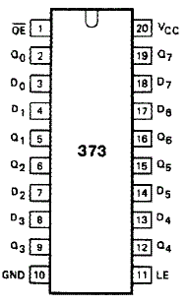
fig 2(i) pin diagram of 74LS373 Latch

How It Works:
•Control Pins LE & OE
•8 Data Inputs D0-D7
•8 Data Outputs Q0-Q7
•Vcc & GND.
Output Enable allows Q0-Q7 to output the data currently held in the D-FlipFlop Latches.
Latch Enable enables the data currently on D0-D7 to overwrite whatever the D-FlipFlop Latches currently have.
8. RED LED:
Light-emitting diode:

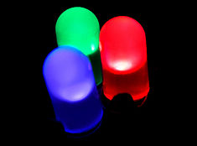
fig 2(j) Red, pure green and blue LEDs of the 5mm diffused type
Type | Passive, optoelectronic
Working principle | Electroluminescence
First production | 1968^{[3]}
Electronc symbol
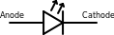
Pin configuration | Sym. 2(a) symbol of LED  anode and cathode

A light-emitting diode (LED) is a semiconductor light source.LEDs are used as indicator lamps in many devices and are increasingly used for other lighting. Appearing as practical electronic components in 1962,^{[5]} early LEDs emitted low-intensity red light, but modern versions are available across the visible, ultraviolet, and infrared wavelengths, with very high brightness.
When a light-emitting diode is forward-biased (switched on), electrons are able to recombine with electron holes within the device, releasing energy in the form of photons. This effect is called electroluminescence and the color of the light (corresponding to the energy of the photon) is determined by the energy gap of the semiconductor. An LED is often small in area (less than 1 mm²), and integrated optical components may be used to shape its radiation pattern.^{[6]} LEDs present many advantages over incandescent light sources including lower energy consumption, longer lifetime, improved physical robustness, smaller size, and faster switching. LEDs powerful enough for room lighting are relatively expensive and require more precise current and heat management than compact fluorescent lamp sources of comparable output.
Light-emitting diodes are used in applications as diverse as aviation lighting, automotive lighting, advertising, general lighting, and traffic signals. LEDs have allowed new text, video displays, and sensors to be developed, while their high switching rates are also useful in advanced communications technology. Infrared LEDs are also used in the remote control units of many commercial products including televisions, DVD players, and other domestic uses.

Fig 2(k) Practical use of led
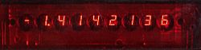
9. Double sided pcb :

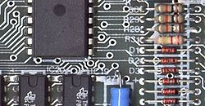

Fig 2(l) specimen of a fabricated pcb
A populated PCB, showing the conductive traces, vias (the through-hole paths to the other surface), and some mounted electrical components
A printed circuit board, or PCB, is used to mechanically support and electrically connect electronic components using conductive pathways, tracks or signal traces etched from copper sheets laminated onto a non-conductive substrate. It is also referred to as printed wiring board (PWB) or etched wiring board. Printed circuit boards are used in virtually all but the simplest commercially produced electronic devices.
A PCB populated with electronic components is called a printed circuit assembly (PCA), printed circuit board assembly or PCB Assembly (PCBA). In informal use the term "PCB" is used both for bare and assembled boards, the context clarifying the meaning.
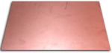
Fig 2(m) single sided pcb

Fig 2(n) double sided pcb
Alternatives to PCBs include wire wrap and point-to-point construction. PCBs must initially be designed and laid out, but become cheaper, faster to make, and potentially more reliable for high-volume production since production and soldering of PCBs can be automated. Much of the electronics industry's PCB design, assembly, and quality control needs are set by standards published by the IPC organization.

CHAPTER 3
PCB Fabrication by using Eagle software

Basics:
We have made a schematic (myname.sch) file which contains our circuit diagram & a PCB board layout (myname.brd) file. Each file has its own editor window. At any time we will change just one of these but the two are linked, so that the connections & components on the schematic always exist on the board. For example if we try to delete components on the board we will be asked to make the change on the schematic first.
EAGLE has an excellent undo command (Edit->Undo or Ctrl-Z) which allows us to undo any command. If the screen looks wrong at any stage, View->Redraw (F2) is use to refresh the display.
EAGLE is very forgiving - any part of the circuit can be modified at any time, providing the auto-router is run again to sort out track changes.

Step 1: Schematic Creation:
Make a project for PCB design-
Start the EAGLE Control Panel application. Create a new project:
File->New->Project.
Rename the project if we wish as follows: the control panel window indicates whether a project is open with a green circle next to the project name. Click this if necessary to close the project. Then
Right-click->Rename
on the project's name. After having renamed the project you can reopen it.
Right-click on the
Project name ->New->Schematic.
The schematic window will open. Inside the schematic window:
File->Save as (choose a suitable name for your schematic sheet. NB - the freeware version of EAGLE allows only one sheet per design).

Open component libraries-
By default all the standard EAGLE libraries are open which makes it inconvenient to select our components from the EEE library.

Add components to schematic-
Edit->Add-> Select component.
Each open library in the ADD window contains a list of components (click + if not visible). The component schematic symbol and package layout appear in the two windows to the right of the library window. Each component has a description. After identified the correct component and package (component & package will be visible in the two windows) click OK to start the ADD procedure. The ADD window will vanish and a schematic outline will track the cursor when it is over the main schematic sheet window. Left-click to place each component. Right-click before placing to rotate the component. Any number of the selected component can be added. To stop the ADD procedure select Edit->Stop Command.
Any number of components can be added to schematic in any order. However components can also be moved after adding, with the Edit->Move command, or rotated with the Edit->Rotate command. Note that these menu commands can also be selected using the buttons on the left side of the schematic sheet window.

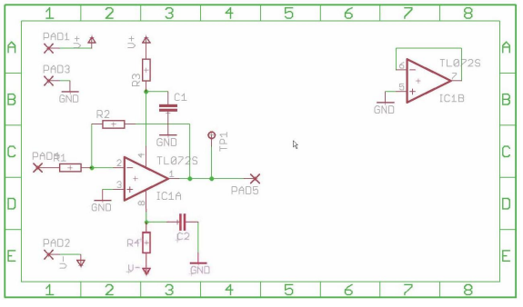
Fig 3(a) circuit components connections

All the operations selected from menus can also be accessed via buttons (hover mouse over button icons to see what each do). Most useful are the zoom buttons (top middle), and the Move button, Delete button Stop button . When a command is active its button, and the stop button, will be highlighted. In this case right-clicking on a schematic object will invoke the command. A short description of the command is displayed on the bottom window edge.

Add a frame to your schematic-
To make the schematic look neater add a frame (Draw->Frame) clicking on the corners of the frame. It can be deleted and redrawn at any time.

Operating on groups of components-
To move the group of components Edit->Group followed by either left-click and drag to select rectangle, or left-click any number of times to draw a polygonal boundary followed by right-click. Now the grouped components will be highlighted in red. If the group is wrong just repeat the operation till have the correct group. Then Edit->Move and right-click will select the group for moving, left-click will terminate the move.

Step 2: Add nets to schematic:

Use the Draw->Net command to connect components. DO NOT use Draw->Wire.
Draw->Net
Left-mouse click on end of source pin or wire, left-mouse click when a change of direction in the wire is required, left-mouse click on the destination.
A connection will be made and
highlighted green with connected wires indicated by a bobble. Note that single right-angle bends will be made automatically, and that right-mouse click during the net command will cycle between different possible wire directions.

Step 2a Add supply connectors to the schematic-

Supply connectors are a special type of component which does not exist physically on the PCB. Supply connectors have one more very clever use. Some ICs have supply pins which do not show on the schematic symbol. These will be automatically connected to a net with the correct supply connector (which has the same name as the pin). If we do not have a supply connector with the correct name it will result in an ERC error.
IMPORTANT: to make this connection visible on the schematic use Draw->Label to add a label (which will display the net name) to each subnet so joined.

Step 2b add I/O pads and testpoints to the layout-

To get signals on and off the PCB we need either connector components or connecting wires. The best way to join wires to a prototype PCB is via terminal pads which have circuit pins soldered - wires can then be soldered to the pins. Add the PAD-TERMINAL component from the EEE library to allow wires for the V+, V- and GND supplies.
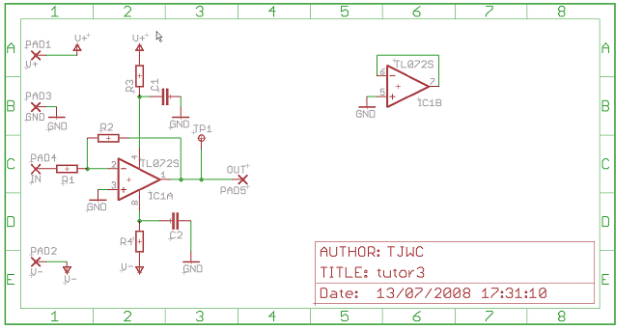
Fig 3(b). A schematic with nets and supply connectors added.

Step 3: Electrical Rule Check:

When we think we have connected everything we must do an ERC which will identify disconnected pins, nets which are next to each other but not connected, etc.
Tools->ERC
Figure 3
The error messages indicate what is wrong. The error check is quite intelligent and knows about power supplies, inputs, outputs, etc. Click on a message to highlight the corresponding 7
error on the schematic.
ERC messages indicate either errors - must be mended - or warnings - will not stop board layout but nevertheless indicate a problem.
One common source of ERC error is when wires which we want to connect look as though they connect are in fact not joined. Where a wire joins the middle of another there must be a green circle (Draw->Junction) to indicate connection. If we click on any part of a net it will highlight all connected wires and component endpoints. When we encounter such an error simply delete (Edit->Delete) line segments around the problem and rewire again (Draw->Net).
Figure 4
Before make the board schematic must pass ERC. POWER warnings which relate to IC supply pins connecting to the wrong net are sometimes unavoidable.
Finally all ERC errors have been corrected except some understood POWER and “no value” warning errors. Where an error is understood it can be approved to prevent future display.

Step 3a - Finishing the Schematic:
Now we have got a schematic which passes its ERC and can be used to generate a PCB.

Board Creation & Layout
Step 4: Create the board
Fig 3(c) schematic of switch to board of the circuit

File->Switch to Board
The board consists of all components, with connections shown as a rats-nest, and a rectangular wire outline (default 100mmX80mm) which represents the board area.

Option->User interface->layout->tick white or coloured
Figure 6: initial rats-nest of schematic components outside the PCB outline, with white background. Note the cross indicating (0,0).
Change the board size-
The wire rectangle defines where the board will be cut. To change the board size Edit->Move and left-click near the middle of the top or right side of the rectangle to pick it up.
We will have to reposition all our components.

Fig 3(d) components connected with top and bottom connections

Step 5: Position the components inside the board outline-

Move the components one by one inside the rectangular board outline (Edit->Move) and position them. When all components are on the board in the correct positions, start the auto-router.

Step 6: Route the tracks-
Tools->Auto... This has many options, but the EEE defaults (which you loaded via ee_autoroute.ctl) normally work fine so click OK. The rats-nest connections will be changed into routed PCB

Fig 3(e) final schematic

NOTE – dense circuits may get less than 100% routing. In Step 8 when add poured copper connected to V- this will simplify routing and may cure problems – so do not despair at this stage. Layout optimisation should be done AFTER step 8, when the final tracking is known.

Step 7: Pour Copper-
PCBs should normally have all area not used for tracks covered with copper "ground plane" to reduce high-frequency noise. This does not interfere with the normal tracks, in fact it can be used to reduce the tracks required. Normally, all "poured copper" is connected to a single circuit supply connector.

Select from the top toolbar drop-down box the layer (top or bottom) on which you want to place the polygon from the top toolbar. (All other options can be unchanged).

Poured copper will automatically join with pins on its own supply net. These pins will connect copper on the two sides if both sides are same supply. HOLE-VIA components can be added to join together both sides at other places. They must be connected on the schematic to the net (V-,GND,etc) that is used for the poured copper, & may then be positioned as required on the layout. This will allow the copper fill to reach areas on the board only filled on one side.

Step 8: Final Touches-
Any part of design schematic or board can be modified at any time, with new auto-routing managing the new layout.

Fig 3(f) final schematic with top and bottom connections

Printing the Schematic-
We can export an image of the schematic (.png) at a specified resolution to a file using File->Export->Image. This can then be printed. Alternatively we can print the schematic with File->Print. The page limit option allows to specify that a larger schematic is automatically shrunk down to only one page.

Double Sided PCB Fabrication:

After circuit designing for both side i.e. top and bottom side same as that of single sided pcb, in eagle CAD is available for make double sided pcb with selection of different layers.
In Eagle CAD, either click on the CAM processor icon or choose CAM processor from the file menu.
Next; once the CAM dialog box is open make the following settings then press the Process Job button:
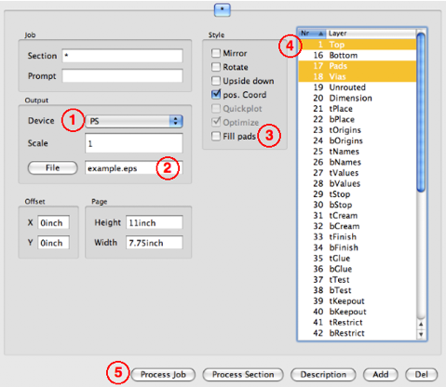

Fig 3(g) selection of the layer
- Choose PS (for Postscript) in the Device list.
- Give top layer a name. Uncheck Fill pads. This way the center of the pad will have a hole which will help aim your drill.
- For the Top layer, we have to choose (Top, Pads and Vias) for the Bottom layer choose (Bottom, Pads and Vias).
- Click the Process Job button to save your file.
After produced the top layer, done the same again but deselect "Top" in the right column and choose "Bottom" and change the name before hit the Process Job button again. Print the files on a laser printer:
Very important, this also tests to make sure that the printer and or computer has not changed the scale of the drawing.
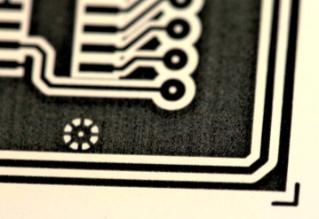
Fig 3(h) specimen of pcb
The next step in the transparency tune-up is to fix any holes (areas that are not supposed to be transparent) in the black areas with a felt tip pen. For this, we matched the holes both sides through drilling.
Development: As soon as possible, immerse the board in the developer solution. This is done by the etching process.I've had good results using a disposable foam paint brush to gently brush over the exposed surface until the non-desired area melts off the board. Once the exposed areas are clear (you see copper) remove the board from the developer and rinse under running water.
Etching: We have use Ferric chloride for this. It's messy stuff but easier to get and cheaper than most alternatives.
It attacks ANY metal including stainless steel, so when setting up a PCB etching area, use a plastic or ceramic sink.
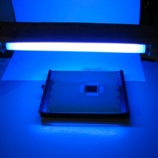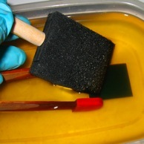

fig 3(i) etching process
Note: Examine the board closely in the areas that there is no resist. Make sure that there is no more resist film in those areas. If any film is remaining for etching then return the board to the developer. Rub a little with the foam brush and rinse once again.
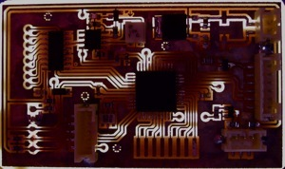

Fig 3(j) pcb after etching process

Placing Components: Generally, it is best to place parts only on the top side of the board. First place all the components that need to be in specific locations. This includes connectors, switches, LEDs, mounting holes, heat sinks or any other item that mounts to an external location.
Give careful of thought when placing component to minimize trace lengths. Put parts next to each other that connect to each other. Doing a good job here will make laying the traces much easier.
ICs should be arrange in only one or two orientations: up and down, or, right and left. Align each IC so that pin one is in the same place for each orientation, usually on the top or left sides.
Position polarized parts (i.e. diodes, and electrolytic caps) with the positive leads all having the same orientation. Also use a square pad to mark the positive leads of these components.
Placing Power and Ground Traces:
After the components are placed, the next step is to lay the power and ground traces. It is essential when working with ICs to have solid power and ground lines, using wide traces that connect to common rails for each supply. It is very important to avoid snaking or daisy chaining the power lines from part-to-part.
One common configuration is to use the bottom layer of the PC board for both the power and ground traces.
Drilling (Manually):
To make holes on PCB we need a drill, a good vertical drill stand and drill bits.
To drill fibreglass (FR4) board you must use tungsten carbide drill bits because fibreglass eats normal high-speed steel (HSS) bits very rapidly. Although HSS drills are good for odd larger sizes (>2mm).
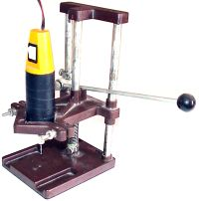

Fig 3(k) drill machine
Small drills for PCB usually come with either a set of collets of various sizes or a 3-jaw chuck - sometimes the 3-jaw chuck is an optional extra, and is worth getting for the time it saves changing collets. For accuracy, however, 3-jaw chucks aren't brilliant, and small drill sizes below 1mm quickly form grooves in the jaws, preventing good grip.

CHAPTER 4
Conclusion

In this project we have done the task of fabrication of double sided pcb successfully which was newly introduced to us. This part of project results mainly for the selectivity of software for circuit designing, height of the components mounted on the pcb, to be careful about etching process and most important the soldering process through which all tracks are connected in proper way.

In next stage the programming of pic microcontroller will be done for which MPLAB IDE and MP C18 Compiler will be used.

This project is actually a real world application basically implemented on the concept of interfacing of a led pattern with the help of 5 latch ic’s which are bi-directional buffers also, with a microcontroller pic 18f452.

REFERENCES

    - www.pyroelectro.com
    - Wikipedia
    - Google .com
    - PIC Microcontroller and Embedded Systems- Muhammad Ali Mazidi, Rolind D. Mckinlay, Danny Caussey

